1. Replace this with below: 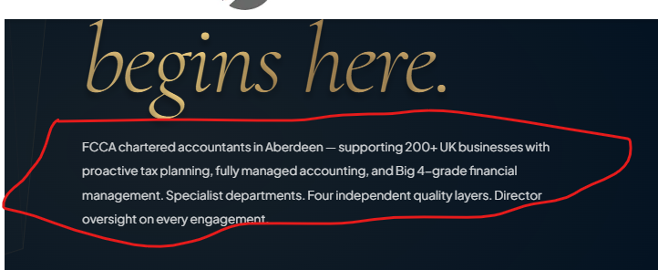
Fellow of the Association of Chartered Certified Accountants (FCCA) and Economics (Honours) graduate of the University of Aberdeen, our founder went on to manage complex international group accounts at Subsea 7, a multibillion-pound oil and gas contractor, to Big 4 audit standards imposed by Deloitte and EY.
A2Z was founded after seeing growing businesses consistently underserved by accountants treating compliance as a box-ticking exercise — and built the finance function they deserved.
A2Z is not a compliance only firm. It is the fully managed finance function that ambitious businesses deserve.
2. Remove this one as it is already repeated below it.
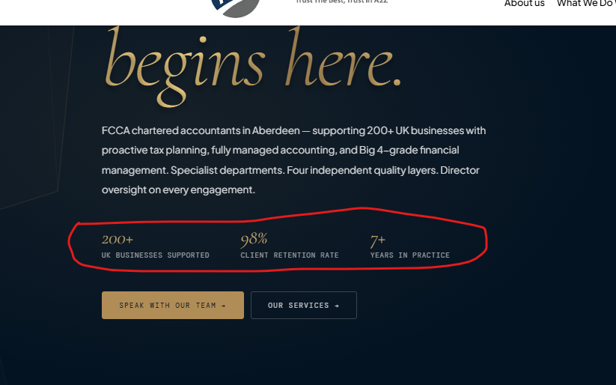
3. Correct the trust badges here and make the banner thinner
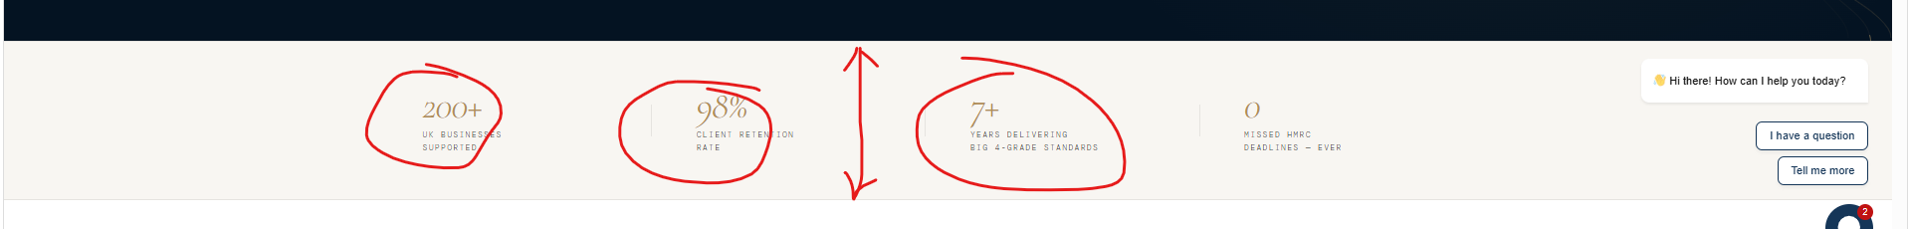
750+ BUSINESSES SUPPORT
100% CLIENT SATISFIED
10+ YEARS IN PRACTICE
4. We will remove this content here and I instead have our teams’ pictures/profiles on it.
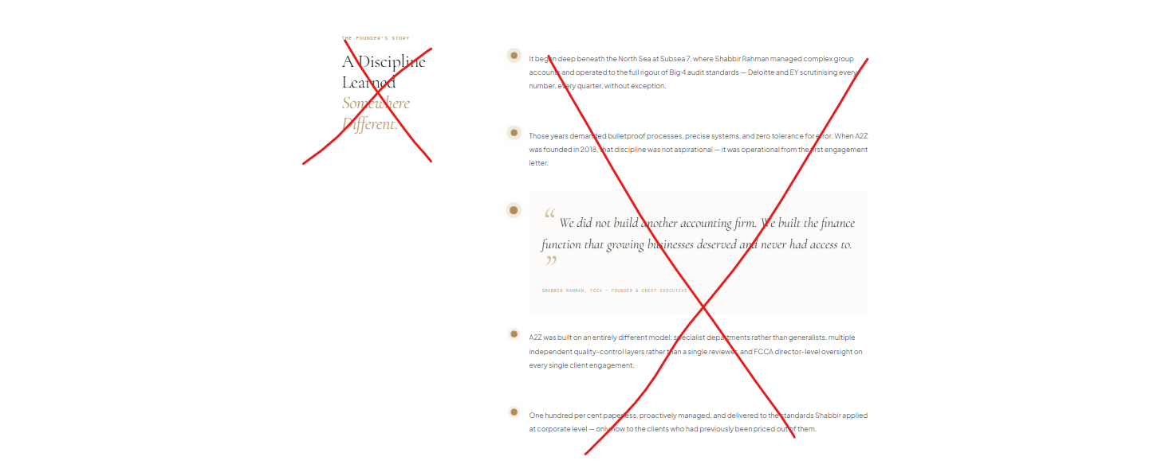
5. Remove the things that are crossed and enlarge texts I circled.
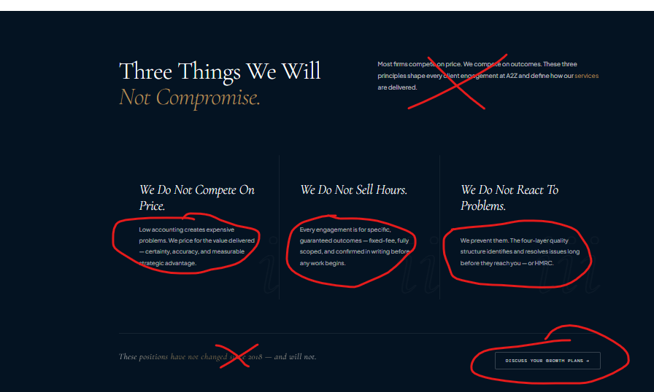
Also, it say “Low accounting…”? Needs to say “Low quality accounting…”

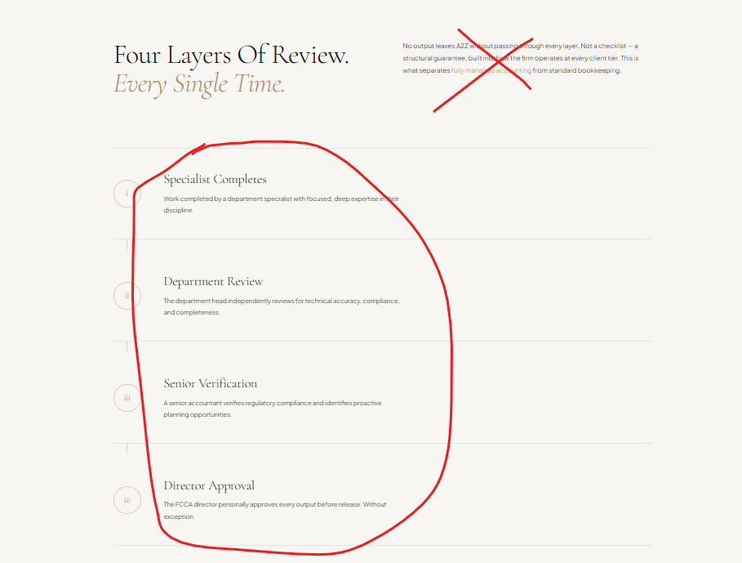
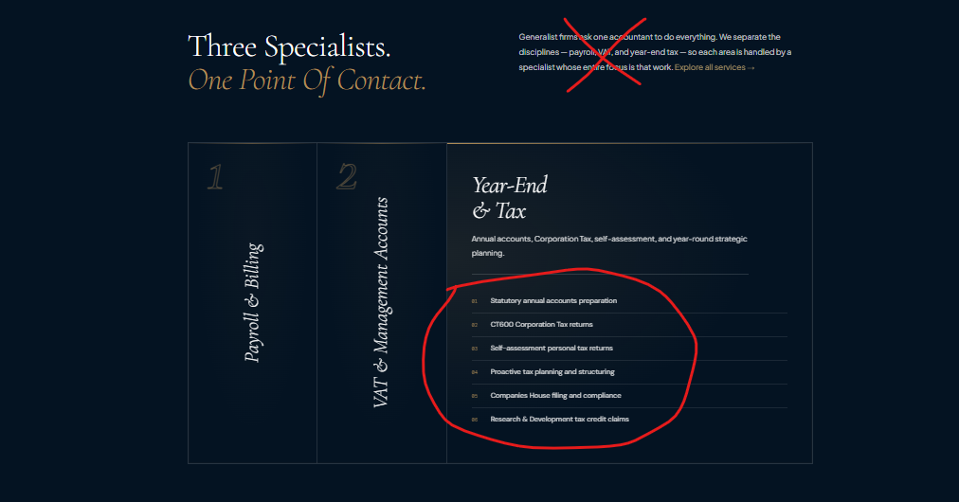
Also for above, instead of saying “One Point Of Contact.” Say “Each Brings a Depth of Relevant Expertise & Provides Fast Turnaround.”
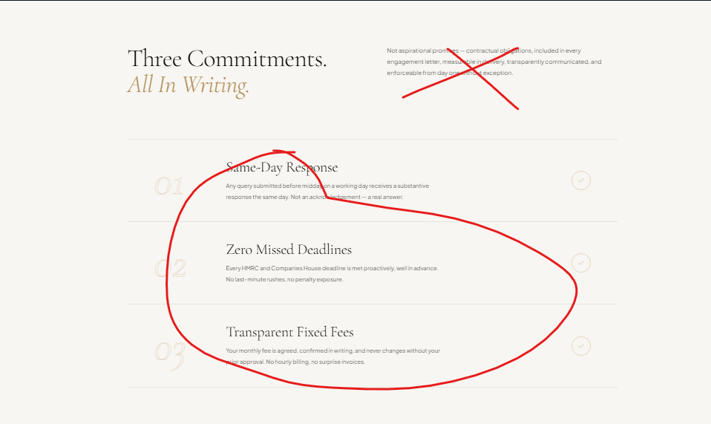
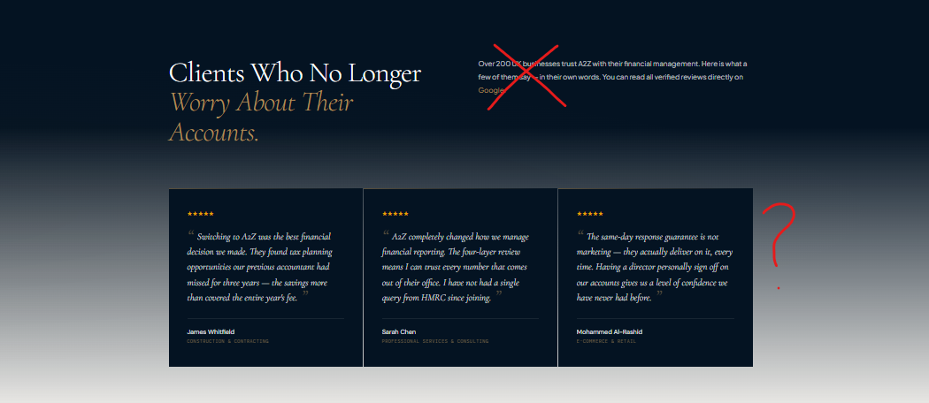
Also these are fake reviews you need to replace with real!
